Taylor Adams

MIS 505

Dr. Johnston

4/16/2021

**Packet Tracer Project Documentation**

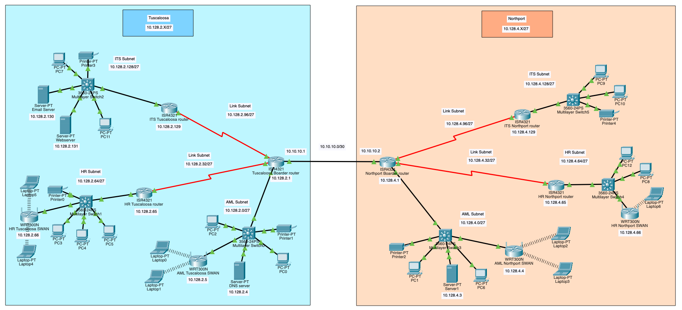

**Network Topology Justification and pricing**

Pricing

|  |  |  |  |
| --- | --- | --- | --- |
| **Product** | **Price** | **Quantity** | **Total** |
| ISR 4321 | $1250 | 6 | $7500 |
| 3560-24PS | $100 | 6 | $600 |
| WRT300N | $60 | 4 | $240 |
| **Total:** | ---------------------- | ---------- | **$8340** |

The connections used it the network will be connected with copper and serial DTE connections.

**Justification for components:**

The wrt300N was recommended in the case. The 4321 router is recommended because it is a best fit model with moderate performance at a low cost compared to newer routers. The 3560 switches are recommended because they offer 24 ports each, which should be enough for the bank’s employees, servers and services.

**Network and subnet stats**

Tuscaloosa

Initial IP: **10.128.2.0/24**

Final IP: **10.128.2.X/27**

DNS Server: **10.128.2.4**

Webserver: **10.128.2.131**

Email Server: **10.128.2.130**

|  |  |  |  |
| --- | --- | --- | --- |
| **Network Name** | **IP Range** | **Default Router** | **Wireless Routers** |
| AML Subnet | 10.128.2.0 - 10.128.2.31 | 10.128.2.1 | 10.128.2.5 |
| Link Subnet (HR) (AML) | 10.128.2.32 - 10.128.2.63 | -------------------- | -------------------- |
| HR Subnet | 10.128.2.64 - 10.128.2.95 | 10.128.2.65 | 10.128.2.66 |
| Link Subnet (ITS)(AML) | 10.128.2.96 - 10.128.2.127 | -------------------- | -------------------- |
| ITS Subnet | 10.128.2.128 - 10.128.2.159 | 10.128.2.129 | -------------------- |

Tuscaloosa Subnetting

Subnets Required: **5 | 2^3 = Borrow 3 bits**

Subnet Mask applied: **/27**

Subnet Mask: **255.2255.255.11100000/27 = 255.255.255.224/27**

|  |  |  |
| --- | --- | --- |
| **Network Name** | **Bits** | **Network IP** |
| AML Subnet | 000|00000 | 10.128.2.0/27 |
| Link Subnet (HR) (AML) | 001|00000 | 10.128.2.32/27 |
| HR Subnet | 010|00000 | 10.128.2.64/27 |
| Link Subnet (ITS)(AML) | 011|00000 | 10.128.2.96/27 |
| ITS Subnet | 100|00000 | 10.128.2.128/27 |

Northport

Initial IP: **10.128.4.0/24**

Final IP: **10.128.4.X/27**

DNS Server: **10.128.4.3**

|  |  |  |  |
| --- | --- | --- | --- |
| **Network Name** | **IP Range** | **Default Router** | **Wireless Routers** |
| AML Subnet | 10.128.4.0 - 10.128.4.31 | 10.128.4.1 | 10.128.4.4 |
| Link Subnet (HR) (AML) | 10.128.4.32 - 10.128.4.63 | -------------- | -------------------- |
| HR Subnet | 10.128.4.64 - 10.128.4.95 | 10.128.4.65 | 10.128.4.66 |
| Link Subnet (ITS)(AML) | 10.128.4.96 - 10.128.4.127 | -------------- | -------------------- |
| ITS Subnet | 10.128.4.128 - 10.128.4.159 | 10.128.4.129 | -------------------- |

Northport Subnetting

Subnets Required: **5 | 2^3 = Borrow 3 bits**

Subnet Mask applied: **/27**

Subnet Mask: **255.2255.255.11100000/27 = 255.255.255.224/27**

|  |  |  |
| --- | --- | --- |
| **Network Name** | **Bits** | **Network IP** |
| AML Subnet | 000|00000 | 10.128.4.0/27 |
| Link Subnet (HR) (AML) | 001|00000 | 10.128.4.32/27 |
| HR Subnet | 010|00000 | 10.128.4.64/27 |
| Link Subnet (ITS)(AML) | 011|00000 | 10.128.4.96/27 |
| ITS Subnet | 100|00000 | 10.128.4.128/27 |

**DHCP and Static reservations**

The first 9 address of every subnet are reserved for static routing

Ex: AML subnet for Tuscaloosa has reserved static address for 10.128.2.1-10.128.4.9.

Ex2: HR subnet for Northport has reserved static addresses for 10.128.4.33-10.128.4.42

**Network linkage**

The two networks Tuscaloosa and Northport are linked together through an ISP’s network. Alternatively, a VPN could be set up in the Tuscaloosa location to allow Northport to have network access to Tuscaloosa. The most secure way to link the networks would be a private physical connection between the two sites.

**\*The packet tracer file was created on Mac.**